Lable positions corresponding to each batch of data:
Bach1:
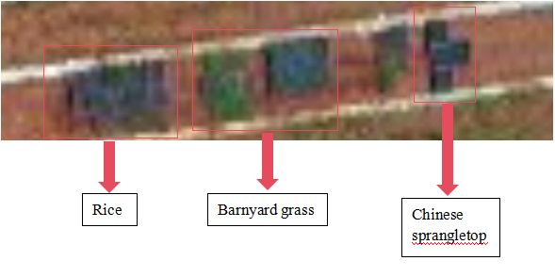
Batch2:
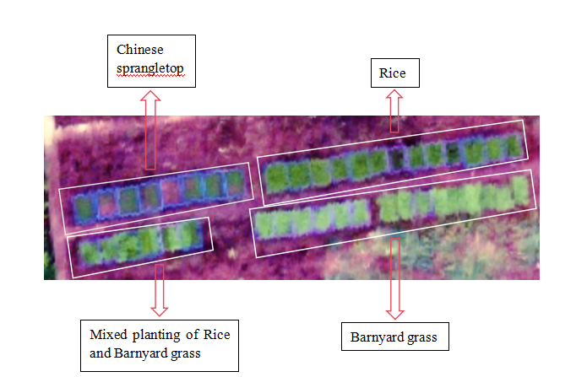

Mixed planting-position of Rice and Barnyard grass（0：Rice;1:Barnyard grass
）：

Batch3:
